**New Implementation**  
  
**Matching Grants:**  
  
Lets say I create a fundraiser with end date as July 29, 2011. So, the countdown in my FR shows up as 3 days (Today being July 26)

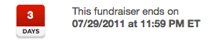  
  
Now create a matching grant. Make sure it is "current", meaning set the start date as today (July 26) and end date as July 28th. So, the countdown reflects the matching grant deadline, which is 2 days.  
  
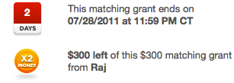  
  
Now make a donation of $400 towards this Fundraiser. Note that the countdown defaults to the FR end date since the matching grant has been met.  **Note: The matching grant text has been updated since the matching grant has been met**

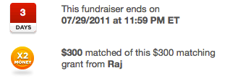

Once the goal date of the FR has been reached (July 29th), the MG will still be visible on the FR page  
  


This will always remain as it is on the FR page until and unless the admin closes the matching grant.

**Challenge Grant:**

Lets say I create a fundraiser with end date as July 29, 2011. So, the countdown in my FR shows up as 3 days (Today being July 26)



Now create a challenge grant. Set the challenge grant number to 1. So 1 donation is needed to unlock the challenge grant. Also, lets set the start date as today (July 26) and end date as July 28th. So, the countdown reflects the challenge grant deadline, which is 2 days.

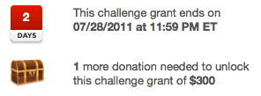

Now make one donation to this Fundraiser. Note that the countdown defaults to the FR end date since the challenge grant has been satisfied. **Note: that the chest icon is now open**

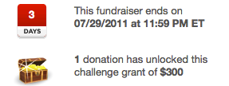

Once the goal date has been reached (July 29th), the MG will still be visible on the FR page  


This will always remain as it is on the FR page until and unless the admin closes the challenge grant.

**We didn’t make any changes to the email notifications that are being sent out while creating/closing the grants. So, that should all work as it used to.**